Germany’s Environment Minister: Make Fracking Illegal
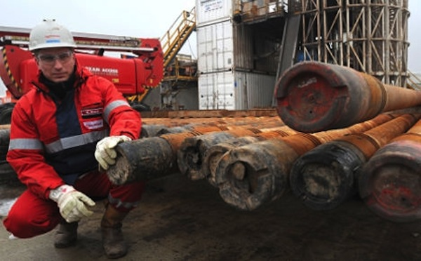
EDUCATE! ENERGY, FRACKING, GERMANY

By DPA, www.thelocal.de

April 3rd, 2014

Germany’s environment minister has called for the controversial gas extraction technique known as “fracking” to be made illegal. Her comments came ahead of an emergency energy summit.
The country’s 16 state premiers were set to meet on Tuesday evening in Berlin in an attempt to smooth over disagreements around the financing of the country’s switch over to renewable energy, known as the Energiewende.
Ahead of the meeting, Environment Minister Barbara Hendricks said Germany should never consider turning to fracking as a solution for its energy needs, despite the success of the technology in the USA.
Fracking involves blasting water mixed with sand and chemicals at high pressure into rocks, releasing the gas.
“Unlike the USA, our country is densely populated and small,” Hendricks told the Passauer Neue Presse on Tuesday.
She added that not only would a successful commercial fracking industry in Germany be “wishful thinking” but that “a rethinking of our energy policy should take us away from fossil fuels – no matter where they come from.”
Germany’s coalition government rejected the use of fracking when it formed in December last year, but Hendricks wants to go further and enshrine a ban in law.
“The coalition agreement is very clear [on fracking], she said. “Drinking water and health are an absolute priority for us. We reject the use of environmentally toxic substances. We will enshrine it in law.”
Energy meet
Economy and Energy Minister Sigmar Gabriel and Chancellor Angela Merkel have been pushing for Germany’s 16 states to come to an agreement on capping surcharges on wind and biogas energy plants.
Gabriel wants to cap green energy surcharges paid to renewable electricity producers after a certain point.
For onshore wind, this would kick in after 2,500 megawatts of new capacity had been installed. For biomass, it would be much lower at just 100 megawatts. Critics say this could kill off biomass altogether.
Premieres of northern states – which tend to have a large proportion of the country’s wind turbines – say putting caps on wind power will slow down the development of the industry and hinder the change over in general.
Schleswig-Holstein’s state premier Torsten Albig said a lot of turbines in his state were being upgraded and they should not be included in the 2,500 megawatt cap.
In Lower Saxony, politicians want a general lowering of energy tax in order to halt Germany’s rising electricity costs.
Related Posts:
- Report Exposes How TTIP Could Expand Fracking March 8, 2014
- Emails Reveal UK Helped Shale Gas Industry Manage Fracking Opposition January 19, 2014
- Fracking Company Fights Dirty to Undermine Referendum March 17, 2014
- ‘Elves’ Set Up Frack Rig On Governor Quinn’s Lawn December 26, 2013
Fracking Waste Being Dumped Off California Coast March 3, 2014

